Assignment 3 Deadline: 4th December, 2023

1. You are hired in FAST HR department where you need to solve a problem where they want to assist their faculty members with the teaching assistant. The Teaching assistant will be a student of university while he will also be a faculty member at the same time his designation will be “teaching assistant”. His id will be same as student id and other personal information can also be extracted from the student.
2. Implement the following class diagram, write appropriate main function make objects and call all the methods to display the proper outputs. Use operator overloading instead of function calling where required

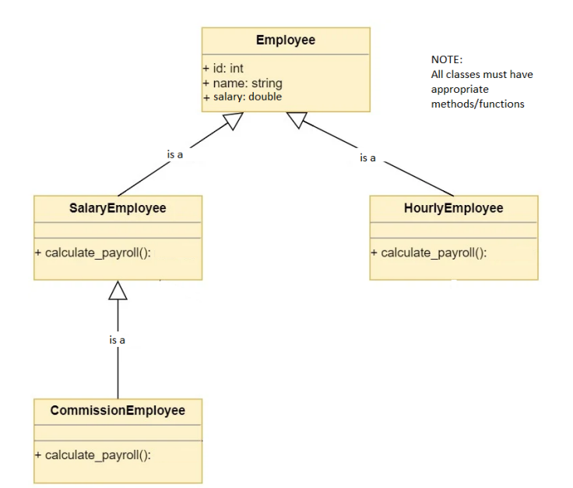

1. There is a system in an office which has some info associated with it. One system has single set of information so there must be one instance of SystemInfo class. Apply Singleton design pattern to this scenario so client could read same info of system from any global access point.

